MARKETING DEPARTMENT

Case understanding:

The case concerns an Indian food company, “Ramalingam Foods” that is considering expanding its business to other parts of the world. Ramalingam Foods found success selling packaged food during the emergency and has subsequently continued to manufacture and sell similar products as part of its core business in recent years. The company's product portfolio has expanded beyond batter to also include instant and easy-to-prepare candies and snacks. Now son of the company's founder at the helm, the company is now looking to expand into overseas markets where it believes its food products will be well received.

BCS Solution Summary:

The Solution Provided talks about: SWOT Analysis, Our Objectives & marketing strategies , STP Analysis ( Segmentation , Targeting & Positioning). Our Product not only focuses on Indian Origin People but embraces every other Origin People to try out our Food. We have also looked into the Promotional & Marketing Expenses & rationale behind why we Geographically wants to Extend our Business to particular Regions.

Solution

Marketing Strategy:

Our marketing strategy aims that our product has sufficient shelf space and customer appeal at the retail store in your target market. This is possible through strategic relationships with supply chain partners, retailers, and customers themselves, with proper product placement and promotion. The marketing strategy must ensure that the product takes up sufficient shelf space and attracts shoppers from retail locations in the target market. This is possible through strategic relationships with supply chain partners, retailers and buyers through the correct positioning and promotion of products.

Mission/ Marketing Objectives :

- Enter new International Market
- To Become Market Leader by Expanding in other Countries where their product gets accepted & recognized
- Achieving Market share of 10% in 1 year of Expansion into new market
- Retaining Existing Customer base by introducing new product
- Increasing Customer base by reaching to the right target audience & making its presence felt
- Brand Equity & Recognition in New Markets

SWOT Analysis:

STRENGTHS  - Existing Customer Base  - Strong Brand Acknowledgment  - Strong hold in Indian Market  - Quality Products | WEAKNESS  - New to International Market (always traded locally)  - Will take time to get hold on International Market  - Huge Investments (R&D)
OPPORTUNITIES  - International Recognition  - Wider Customer Base  - Growth & Expansion  - Diversified Risk  - Increased Profits & Revenue | THREATS  - Politico - Legal Formalities  - Cost: Benefits (Benefit accruing from the investments might not be satisfactorily if their Plan failed)  - Cultural Difference

STP Analysis:

Segmentation

a. Geographic Segmentation: We have Different Regions to segment our Customers like: Middle East, Southeast Counties, Northwest outside India

b. Demographic Segmentation:
- Age Group that lies between 20- 50 years of age.
- Income Level: Different Income Groups of Lower Income, Middle Level, Lower- Middle, Middle- Upper, Upper Income Group
- Occupation: Young- Unmarried, Young- Married, Employed, Self Employed, College Going, Retired, Housewives.
- Family Size: 1-2, 3-4, 5-7

c. Psychographic Segmentation:

- Includes Consumption benefits
- Lifestyle
- Beliefs
- Attitude
- Values 7 morals

d. Behavioral Segmentation:

- User Status: Ex Users, Potential Users, First Time users, Regular Users
- Loyalty Status: Hard Core Loyal, Switchers, Soft Loyal, Shift Loyal
- Readiness stage: Unaware, aware, Informed, Interested, Intending to make a Purchase
- Attitude towards the product: Positive Negative & Indifferent towards the Product

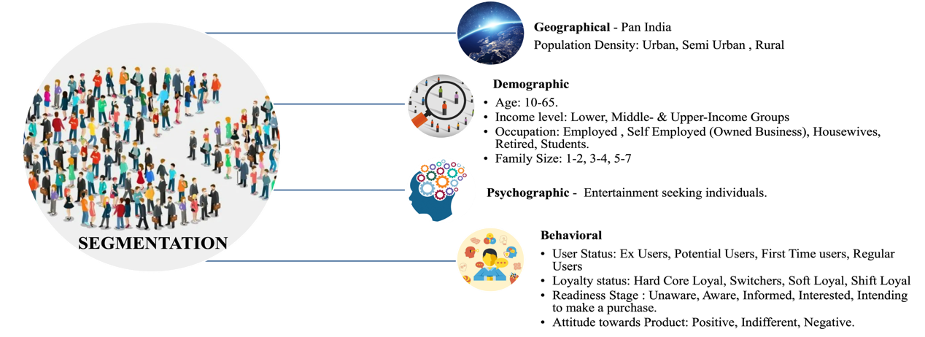

TARGETING:

a. Geographical: Middle east Region. According to our Marketing survey We have Planned to Expand our business to Middle east Regions, focusing on 3 countries:

Saudi Arabia
UAE
Oman

Rationale for choosing these Countries as our target is:

1. Saudi Arabia: As per the MEA Report about Overseas Indian Population, There are 25.95 lakhs of Indians residing in Saudi Arabia. Indians make around 11-14% of Saudi Arabia Population & are the largest Community of expatriates in Saudi Arabia.

2. UAE: There are Approximately 2.62 Million Indian National residing in the UAE which is a major chunk. If we target in UAE, we have a high probability of success

3. Oman: As of 2010 Population Census Reports, Indians Constitutes of around 20% of Oman’s Total population i.e., 2.3 Million. Also, there are 448000 Indian Migrants workers in Oman. India & Oman are linked by Geography, history & culture which fosters friendly & cordial relationship between both India & Oman making it a probable choice for our Business Expansion.

b. Demographic Segmentation:

- Age Group of 20-50 years of age. We have targeted age group of 20 – 50 years of age because this age group includes people who are both out of India due to education and Professional Work. As The Indians in Oman belong to various professions and businesses which made us target both young college ging student & Blue collared workers who are out of India to earn a living.
- Income Groups: Our offerings cater to Lower Middle & Middle Upper Income groups as they are affordable.
- Occupation : We will target people who are Young- Unmarried ( as they are single & lives in Paying guests or Hostels, our Offerings will have high demands in this group), Young – Married ( where both husband & wife are Working professionals , they might more depend on outside cook & deliverables).
- Family Size: Our Business plan is to focus on all the family sizes. Hopefully Family Size of 4-5 will be able to fetch us more revenue as people tend to order foods in large quantity as per different family members choices & tastes 7 preferences.

c. Psychographic Segmentation:

- We Will focus people of Both Indian & Non-Indian Origins.
- Indians who take pride in their cultural Heritage & in their India Cuisine. Who take pride in their cultural foods
- Non-Indians: who are not from India but like diversity & want to know about other culture’s or Country’s cuisines .

d. Behavioural Segmentation:

We will target People on the basis of:

1. User Status: Who are Ex Users & Potential users.
2. Loyalty status: Who are soft loyal & Switchers ( because it is easier as compared to hard core loyal to attract them to your product).
3. Readiness Stage: We will focus our Food Products to people who are aware, informed & interested to try our Product. Although we will also focus on people who are unaware about our Product & those who are informed. This will help us in attracting large customer base
4. attitude: our Main focus is to Target People of other Regions who are Negative Review holder of other Deliverables near their localities

POSITIONING:

“ Ghar Ke Door, Ghar Jaisa Khana” ( Hindi Language)

“ Far from home, home like food” ( English)

This Positioning will help Indian origin people Resonate with the Product. For Non-Indian people we will Launch another Positioning Tagline as : “ Healthy, Easy to Cook food at your doorstep. Running out of time? We are here with our Instant Cook. “

4 P’s:

Product: Instant Cook , Healthy, Delicious, flavoursome Indian Cuisine, Easy to cook.

Place: Super Markets, Marts, Local Shops & Restaurants

Price: Affordable Pricing focusing on lower- Middle & Middle Upper Income Groups

Promotion: Social Media Marketing, Sponsoring events, Web Page Ads, Retarget Marketing, Television Commercials

Promotion Expenses includes:

Middle East Regions
Saudi Arabia: 1.5 Cr.
UAE: 1.5 Cr.
Oman: 1 Cr.

Total Promotional Expense equals to 4 Cr.
In addition to it R&D for conducting Market Research will include 6 Cr.

Total Marketing & Promotional expense: 10 Cr.

Conclusion :

We Devised a Marketing Plan , Studied International Market focusing what would be a good Market to enter, where Indian Nationals form high percentage of population. In order to hit the success in International Market it is very important to know the taste & Preferences of our Target audience so as to keep ourselves updated & make necessary amends whenever market condition changes. Distribution & Supply chain Partners are to be decided & continued Promotion will be carried out for years to come.

